Upper Tribunal
(Immigration and Asylum Chamber) Appeal Number: PA/04114/2018

THE IMMIGRATION ACTS

Determined at Field House without a hearing | Determination Promulgated
On 21 August 2018 | On 30 August 2018

Before

UPPER TRIBUNAL JUDGE RINTOUL

Between

C M
(ANONYMITY ORDER MADE)
Appellant
and

THE SECRETARY OF STATE FOR THE HOME DEPARTMENT
Respondent

DECISION AND REASONS
- On 26 July 2018 I gave the following directions:-
- Having had regard to the decision of the First-tier Tribunal of 10 April 2018, subsequent correspondence and the terms of the grant of permission, it appears that a fax was sent on 3 April 2018 attaching grounds. It is my preliminary view that the decision of the First-tier Tribunal involved the making of an error of law in that the judge proceeded to determine the appeal without considering the grounds submitted on 3 April 2018.
- It is therefore my preliminary view that the decision of the First-tier Tribunal should be set aside and that the appropriate course of action would be to remit the appeal to the First-tier Tribunal for a fresh hearing on all issues.
- Unless within ten working days of the issue of these directions there is any written objection to this course of action, supported by cogent argument, the Upper Tribunal will proceed to determine the appeal without an oral hearing and will remit it to the First-tier Tribunal.
- In the absence of a timely response by a party, it will be presumed that it has no objection to the course of action proposed
- There has been no response to these directions by either party. Accordingly, I am satisfied that neither party objects to the matter being determined without a hearing and has nothing further to say. I am satisfied that that the determination of the First-tier Tribunal did involve the making of an error of law for the reasons set out above, and must therefore be set aside. In the circumstances, owing to a procedural unfairness, the appellant did not receive a fair hearing, and the appropriate course is to remit the appeal to the First-tier Tribunal for a fresh decision on all issues

Summary of conclusions
- The determination of the First-tier Tribunal did involve the making of an error of law and I set it aside.
- The appeal is remitted to the First-tier Tribunal for a fresh decision on all issues.

Signed Date: 21 August 2018
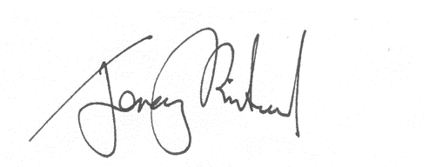
Upper Tribunal Judge Rintoul

