Upper Tribunal
(Immigration and Asylum Chamber) Appeal Number: IA/33851/2015

THE IMMIGRATION ACTS

Heard at Field House | Decision and Reasons Promulgated
On 20.08.2018 | On 30.08.2018

Before

UPPER TRIBUNAL JUDGE GRUBB

Between

PETER OWUSU ANSAH
(anonymity direction not made)
Appellant
and

THE SECRETARY OF STATE FOR THE HOME DEPARTMENT
Respondent

Representation:
For the Appellant: Mr A Otchie instructed through direct access
For the Respondent: Mr C Howells, Senior Home Office Presenting Officer

NOTICE OF DECISION
- Both subparagraphs of rule 40(3) apply to this decision.
- The decision of the First-tier Tribunal (Judge Powell) sent out on 27 September 2017 is erroneous in law. I set it aside.
- The appeal is remitted to be determined de novo by the First-tier Tribunal other than Judge Powell.
- The respondent is directed to serve upon the appellant within 21 days of this decision being sent (i) the respondent’s bundle; and (ii) any evidence relied upon in relation to the issue of the subsistence of the appellant’s marriage, including any evidence from the appellant’s spouse.

Signed 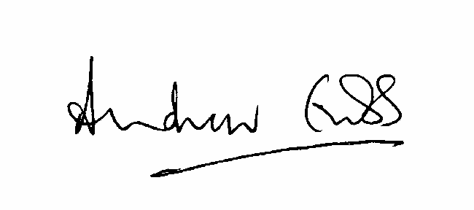

A Grubb
Judge of the Upper Tribunal dated 20 August 2018

