Upper Tribunal
(Immigration and Asylum Chamber) Appeal Number: EA/04845/2016

THE IMMIGRATION ACTS

Determined at Field House without a hearing | Decision & Reasons Promulgated
On 21 May 2018 | On 23 May 2018

Before

UPPER TRIBUNAL JUDGE RINTOUL

Between

SOLOMONA EMEKA AKAEKE
(NO ANONYMITY ORDER MADE)
Appellant
and

THE SECRETARY OF STATE FOR THE HOME DEPARTMENT
Respondent

DECISION AND REASONS

- In the light of Khan v Secretary of State for the Home Department [2017] EWCA Civ 1755 and SM (Algeria) [2018] UKSC 9, the First-tier Tribunal erred in law in concluding that it did not have jurisdiction to hear the appeal. Accordingly, and in the light of the respondent’s policy where, as here, no findings of fact were made, I am satisfied that the appeal can fairly be determined without a hearing.

- I am satisfied that that the determination of the First-tier Tribunal did involve the making of an error of law for the reasons set out above, and must therefore be set aside. Given the nature of the error, I remit the appeal to the First-tier Tribunal for a fresh determination on all issues.

Summary of conclusions

- The determination of the First-tier Tribunal did involve the making of an error of law and I set it aside.

- I remit the decision to the First-tier Tribunal for a fresh decision on all issues

- The appeal must not be before First-tier Tribunal Judge Telford

Signed Date: 21 May 2018
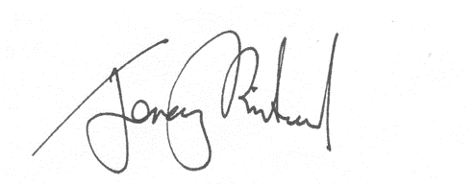
Upper Tribunal Judge Rintoul

